JUNE 2019

WORDS FROM THE GRAND KNIGHT

We are doing new events that have brought some much need funds to our Council. The Pizza Ranch fundraiser has given use over $200 dollars just from one event alone. Plus we are planning another Pizza Ranch Fundraiser for our Council on September 5th and are planning a walking taco fundraiser out front of St. Boniface church after the Sunday morning mass sometime in August or September. We have also adding more CPID fundraiser events this year. So there is a lot of activities here at Council #12855. Plus we have donated $20 to the Soccer Challenge. Which will be on August 31st. So please come out and help with that event.

The Photo below is from the Pizza Ranch Fundraiser event on April 4th. Photographed here from left to right is Our Council Chaplin Fr. Brad Pelzel, Financial Secretary Terry Loutsch, Grand Knight Michael Peters, Treasurer Jim Roethler, Sir Knight David Butler, Lecturer Ron Heyden. Thank you Brothers for supporting our council and making it a fun joyful event.

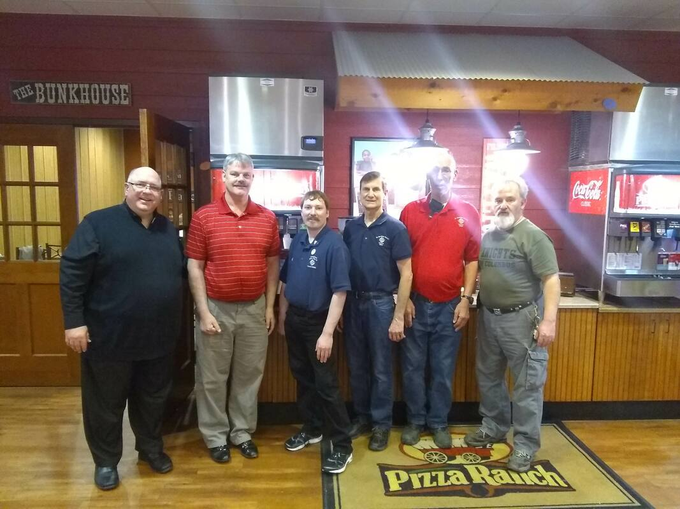

You might have herd that the Iowa K of C Convention is coming to Sioux City next year. That is true it will be here in Sioux City. So if you want to take the 4th Degree please talk to a Sir Knight and we can help you become a Sir Knight at the State Convention. Plus there will be many opportunities to help with planning the State convention.

I have been asked to add a list of members once a year. Because we have had a few changes to the list of members in our council. So I have added it to this newsletter. This list is as of June 7th 2019.

MICHAEL PETERS GRAND KNIGHT OF COUNCIL #12855

Here is the list of the officers of our Council #12855 starting July 1st 2019

Grand Knight Michael Peters

Deputy Grand Knight Parker Sones

Chancellor John Hildman III

Recorder Ron Heydon

Treasurer Jim Roethler

Lecturer Jim Hicks

Advocate Jim Gulbronson

Warden David Butler

Guards Jeff Treglia, Charles Meyers

Trustees Robert Flanders, Pat Vogt
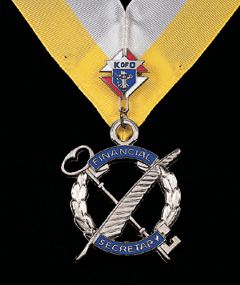 WORDS FROM THE FINANCIAL SECRETARY

Knight of the Month
Ron Heydon for May 2019
Ricardo Rocha for January 2019

Events
All events are subject to change.
For all updates and other info. go to kofc12855.weebly.com
July 1st New Council Officers start date and old 4th degree regalia retired.
July 2nd Monthly meeting at 7pm
Will be at the St. Boniface Hall.
Installation of Officers before meeting.
​
August 6th Monthly meeting at 7pm
Will be at the St. Boniface Hall.
​
August 22nd X'S tailgate 4:30 PM set up tailgate 5:30 PM.
Address 3400 Line Drive. Sioux City, IA 51106
August 31st Soccer Challenge at Memorial Field
Soccer Clinic will be coached by the Bishop Heelan Soccer coaches. The Soccer Clinic Starts at 8 am to 11 am.
​Then the Soccer Challenge will start at 12 pm.
This event is for kids ages 8 to 14.
September 3rd Monthly meeting at 7pm
Will be at the St. Boniface Hall.
September 5th Pizza Ranch Fund Raiser 4:15pm
Tip Money and Donations goes to our Council. 3116 Floyd Blvd. Sioux City, IA
​

